NY State Ranger Frequencies

The frequencies listed below are the ones found on this map:
https://caltopo.com/m/93PH

Sam's Point Tower - Ulster
Rx 159.43500
Tx 151.22000
Tone 94.8

Buck Mtn Tower - Rensselaer
Rx 159.43500
Tx 151.28000
Tone ???

Mt Utsayantha Tower - Delaware
Rx 159.43500
Tx 151.28000
Tone 77.0

Petersburg Tower - Schoharie
Rx 159.43500
Tx 151.28000
Tone ???

Blue Mountain Tower
Rx 159.43500
Tx Maybe 151.2200 or 151.2800 or less likely 151.4300
Tone 131.8

Gore Mountain Tower
Rx 159.43500
Tx Maybe 151.2200 or 151.2800 or less likely 151.4300
Tone 173.8

Dry Hill Tower - Jefferson
Rx 159.43500
Tx 151.28000 )
Tone ???
Gomer Hill Tower - Lewis
Rx 159.43500
Tx 151.28000
Tone 77.0

Panther Mtn Tower - St. Lawrence
Rx 159.43500
Tx 151.28000
Tone 71.9

Starr Hill Tower - Oneida
Rx 159.43500
Tx 151.28000
Tone 100.0

Whites Hill Tower - St. Lawrence
Rx 159.43500
Tx 151.28000
Tone???

Woodhull Tower - Herkimer
Rx 159.43500
Tx 151.28000
Tone ???

Berry Tower - Chenango
Rx 159.43500
Tx 151.28000
Tone 127.3 PL

Georgetown Tower - Madison
Rx 159.43500
Tx 151.22000
Tone 94.8

Ingraham Tower - Broome
Rx 159.43500
Tx 151.22000
Tone ???
Western Finger Lakes
Rx 159.43500
Tx 151.28000
Tone 100.0

Western NY
Rx 159.43500
Tx 151.28000
Tone 127.3

The frequencies above are taken from:
https://www.radioreference.com/apps/db/?inputs=1&aid=614#cats

Make sure to click “Input Frequencies Shown”
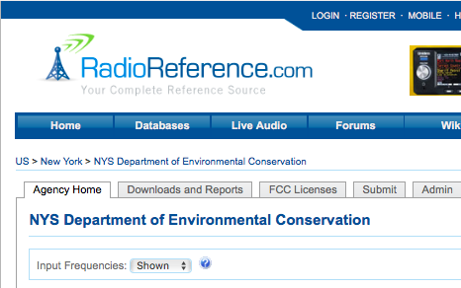

Here are a list of tones from:
https://wiki.radioreference.com/index.php/NYS_Department_of_Environmental_Conservation_(NY)_Unvalidated_Frequencies

They deviate from the ones listed above, not sure exactly what to make of that but I believe the ones above are likely more accurate.

Forest Rangers
- Frequency is 159.4350³
  - Colfax, Ingraham, Utsayantha, Whiteface, Call 141.3
  - Petersburg, McCarthy, Selden, Berry, White's, Chautauqua 103.5
  - Sam's Point, Georgetown, Windham, Dry 114.8
  - Sandalee, Phillsbury, Expansion 136.5
  - Starr 127.3
  - Sugar, Blue, Clove, Gomer 123.0

3. Forest ranger repeater inputs 151.2200 and 151.2800 with various tones.

